NEPAL COLLEGE OF INFORMATION TECHNOLOGY
Balkumari, Lalitpur
Affiliated to Pokhara University

LAB REPORT FOR COMPILER DESIGN


LAB REPORT 1,2,3

Submitted by: Submitted to:
Name: Arpan Adhikari Subash Manandhar
Roll No.: 231309
BECE (6th SEM)

QSN 1: PROGRAM TO CHECK WHETHER INPUT IS AN IDENTIFIER

THEORY
In programming languages, an identifier is the name given to variables, functions, arrays, or other user-defined items. Identifiers must follow specific lexical rules defined by the compiler.

Rules for Identifiers
- Must begin with a letter (a–z, A–Z) or an underscore (_)
- Cannot start with a digit
- Can contain letters, digits, and underscores
- No special characters like @, #, $, %, etc. are allowed
- Should not be a reserved keyword

Concept Used
This program simulates a lexical analyzer phase of a compiler, where tokens are validated based on syntax rules. Functions like isalpha() and isalnum() help classify characters.

//Code

#include <iostream>
#include <cctype>
#include <string>
using namespace std;

bool isIdentifier(string str) {
if (str.empty() || (!isalpha(str[0]) && str[0] != '_')) return false;
for (size_t i = 1; i < str.length(); i++) {
if (!isalnum(str[i]) && str[i] != '_') return false;
}
return true;
}

int main() {
string input;
cout << "Enter a string to check for identifier: ";
cin >> input;

if (isIdentifier(input))
cout << "'" << input << "' is a valid identifier." << endl;
else
cout << "'" << input << "' is NOT a valid identifier." << endl;

return 0;
}

//Output

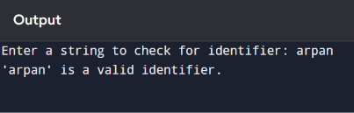

QSN 2: PROGRAM TO CHECK WHETHER INPUT IS A KEYWORD

Theory
A keyword is a reserved word in a programming language that has a predefined meaning and cannot be used as an identifier.

Examples of Keywords
int, float, if, else, return, while, for, class, struct

Concept Used
The program uses a set data structure to store predefined keywords. It then checks whether the given input exists in that set. This simulates how a compiler distinguishes keywords during lexical analysis.

//Code

#include <iostream>
#include <string>
#include <set>
using namespace std;

bool isKeyword(string str) {
set<string> keywords = {
"int", "float", "char", "double", "if", "else", "while", "do", "for",
"return", "switch", "case", "break", "continue", "void", "class", "struct"
};
return keywords.find(str) != keywords.end();
}

int main() {
string input;
cout << "Enter a string to check for keyword: ";
cin >> input;

if (isKeyword(input))
cout << "'" << input << "' is a keyword." << endl;
else
cout << "'" << input << "' is NOT a keyword." << endl;

return 0;
}

//Output

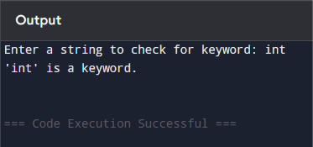

QSN 3: PROGRAM TO CHECK WHETHER INPUT IS AN OPERATOR

Theory
An operator is a symbol used to perform operations on variables and values.

Types of Operators
- Arithmetic: + - * / %
- Relational: < > <= >= == !=
- Logical: && ||
- Assignment: =

Concept Used
The program stores all valid operators in a set and checks if the given input matches any of them. This is part of token classification in the lexical analysis phase.

//Code

#include <iostream>
#include <string>
#include <set>
using namespace std;

bool isOperator(string str) {
set<string> operators = {
"+", "-", "*", "/", "%", "=", "==", "!=", "<", ">", "<=",
">=", "&&", "||"
};
return operators.find(str) != operators.end();
}

int main() {
string input;
cout << "Enter a string to check for operator: ";
cin >> input;

if (isOperator(input))
cout << "'" << input << "' is an operator." << endl;
else
cout << "'" << input << "' is NOT an operator." << endl;

return 0;
}

//Output

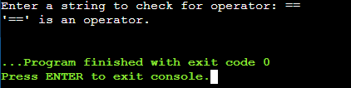

QSN 4: CONSTANT CHECK

Theory
A constant is a fixed value that does not change during program execution. Constants can be classified into:
- Integer constants → 10, -25
- Floating-point constants → 3.14, -0.5

Rules
- May start with + or -
- Can contain digits and at most one decimal point
- Cannot contain alphabets or special symbols

Concept
The program checks:
- Whether all characters are digits
- Whether the decimal point appears only once
This simulates how compilers validate numeric tokens.

//Code

#include <stdio.h>
#include <string.h>
#include <ctype.h>

int main() {
char str[100];
int i, len;
int isInteger = 1, isFloat = 1;

printf("Enter input: ");
scanf("%s", str);

len = strlen(str);

if (str[0] == '"' && str[len - 1] == '"') {
printf("%s is a String Constant.\n", str);
}

else if (str[0] == '\'' && str[len - 1] == '\'' && len == 3) {
printf("%s is a Character Constant.\n", str);
}

else {
for (i = 0; str[i] != '\0'; i++) {
if (!isdigit(str[i])) {
isInteger = 0;
break;
}
}

if (isInteger) {
printf("%s is an Integer Constant.\n", str);
}
else {
int dotCount = 0;

for (i = 0; str[i] != '\0'; i++) {
if (str[i] == '.') {
dotCount++;
}
else if (!isdigit(str[i])) {
isFloat = 0;
break;
}
}

if (isFloat && dotCount == 1) {
printf("%s is a Float Constant.\n", str);
}
else {
printf("%s is NOT a Constant.\n", str);
}
}
}

return 0;
}

//Output

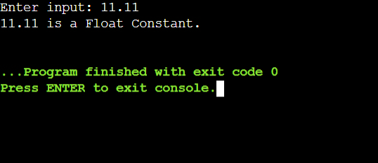

QSN 5: COMMENT DETECTION

Theory
Comments are non-executable statements used to improve code readability and documentation.

Types of Comments
- Single-line comment → starts with //
- Multi-line comment → enclosed within /* ... */

Concept
The program identifies comments by checking:
- Starting characters (// or /*)
- Ending characters (*/ for multi-line)
This is part of lexical analysis where comments are ignored during token generation.

//Code

#include <stdio.h>
#include <string.h>

int main() {
char str[200];

printf("Enter input: ");
fgets(str, sizeof(str), stdin);

int len = strlen(str);

if (str[len - 1] == '\n') {
str[len - 1] = '\0';
len--;
}

if (str[0] == '/' && str[1] == '/') {
printf("Single Line Comment\n");
}
else if (str[0] == '/' && str[1] == '*' &&
str[len - 2] == '*' && str[len - 1] == '/') {
printf("Multi Line Comment\n");
}
else {
printf("Not a Comment\n");
}

return 0;
}

//Output
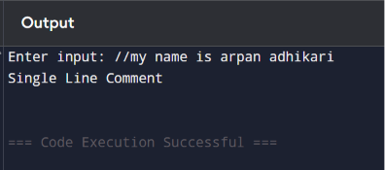

QSN 6: TOKENIZATION

Theory
Tokenization is the process of breaking a program into smaller units called tokens.

Types of Tokens
- Keywords
- Identifiers
- Operators
- Constants
- Punctuation symbols

Concept
The program uses string processing (or regex) to extract tokens from a source string. This step is the first stage of compilation.
Example:
int a = 10;
Tokens → int, a, =, 10, ;

//Code

#include <stdio.h>
#include <string.h>
#include <ctype.h>

int isKeyword(char str[]) {
char *keywords[] = {
"void", "main", "int", "float", "char",
"if", "else", "while", "for", "return", "printf"
};

int n = sizeof(keywords) / sizeof(keywords[0]);

for (int i = 0; i < n; i++) {
if (strcmp(str, keywords[i]) == 0)
return 1;
}
return 0;
}

int main() {
char str[] =
"void main(){int a,b; a=a+b; printf(\"Hello!\"); "
"a=5; b=10; a=a+b; return 0;}";

char token[100];
int i = 0, j;

while (str[i] != '\0') {

if (isspace(str[i])) {
i++;
continue;
}

if (str[i] == '"') {
j = 0;
token[j++] = str[i++];

while (str[i] != '"' && str[i] != '\0')
token[j++] = str[i++];

if (str[i] == '"')
token[j++] = str[i++];

token[j] = '\0';

printf("%s - Constant\n", token);
}

else if (isalpha(str[i]) || str[i] == '_') {
j = 0;

while (isalnum(str[i]) || str[i] == '_')
token[j++] = str[i++];

token[j] = '\0';

if (isKeyword(token))
printf("%s - Keyword\n", token);
else
printf("%s - Identifier\n", token);
}

else if (isdigit(str[i])) {
j = 0;

while (isdigit(str[i]))
token[j++] = str[i++];

token[j] = '\0';

printf("%s - Constant\n", token);
}

else if (strchr("=+-*/", str[i])) {
printf("%c - Operator\n", str[i]);
i++;
}

else {
i++;
}
}

return 0;
}

//Output

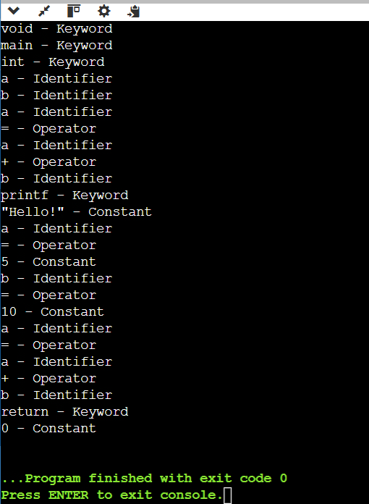

QSN 7: COUNT LINES AND COMMENTS

Theory
Analyzing source code often requires counting:
- Total number of lines
- Number of comment lines

Concept
The program:
- Reads code line-by-line using getline()
- Increments line counter
- Checks for comment patterns (// or /*)
This is useful in:
- Code analysis tools
- Metrics calculation
- Preprocessing stage

//Code

#include <stdio.h>

int main() {
char code[1000];
int i = 0;

int lines = 1;
int single_comments = 0;
int multi_comments = 0;

int in_single = 0;
int in_multi = 0;

printf("Enter the program (end with ~):\n");

while ((code[i] = getchar()) != '~') {
i++;
}
code[i] = '\0';

for (int j = 0; code[j] != '\0'; j++) {

if (code[j] == '\n')
lines++;

if (code[j] == '/' && code[j+1] == '/' && !in_multi) {
single_comments++;
in_single = 1;
}

if (code[j] == '/' && code[j+1] == '*' && !in_single) {
multi_comments++;
in_multi = 1;
}

if (code[j] == '\n' && in_single) {
in_single = 0;
}

if (code[j] == '*' && code[j+1] == '/' && in_multi) {
in_multi = 0;
}
}

printf("\nTotal Lines = %d\n", lines);
printf("Single-line Comments = %d\n", single_comments);
printf("Multi-line Comments = %d\n", multi_comments);

return 0;
}

//Output

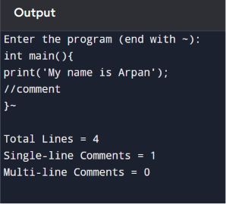

QSN 8: PATTERN RECOGNITION (REGULAR EXPRESSIONS)

Theory
Regular expressions (Regex) are used to describe patterns in strings. In compiler design, regex is used to define tokens.

Given Patterns
- a*b → zero or more a followed by b
- a+ba → one or more a followed by ba
- (a+b)* → any combination of a and b

Concept
The program uses regex_match() to compare input strings with defined patterns. This is directly related to finite automata theory.

//Code

#include <stdio.h>
int main() {
char str[100];
int i, valid = 1;

printf("---------------------------------\n");
printf("Name: Sanjog Sharma -231336\n");
printf("---------------------------------\n");

printf("Enter string: ");
scanf("%s", str);

for (i = 0; str[i] != '\0'; i++) {
if (str[i] != 'a' && str[i] != 'b') {
valid = 0;
break;
}
}

if (valid)
printf("Accepted (matches (a+b)*)\n");
else
printf("Rejected\n");

return 0;
}

//Output
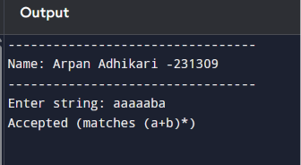

QSN 9: DFA SIMULATION

Theory
A Deterministic Finite Automaton (DFA) is a mathematical model used to recognize patterns in strings.

Components of DFA
- States
- Input alphabet
- Transition function
- Start state
- Accept state

Concept
The program simulates DFA behavior by:
- Checking if input matches identifier rules
- Checking if input is numeric (constant)
- Checking operator patterns
This demonstrates how compilers use automata for token recognition.

//Code

#include <stdio.h>
#include <ctype.h>
#include <string.h>

int isIdentifier(char str[]) {
if (!(isalpha(str[0]) || str[0] == '_'))
return 0;

for (int i = 1; str[i] != '\0'; i++) {
if (!(isalnum(str[i]) || str[i] == '_'))
return 0;
}
return 1;
}

int isConstant(char str[]) {
for (int i = 0; str[i] != '\0'; i++) {
if (!isdigit(str[i]))
return 0;
}
return 1;
}

int isOperator(char str[]) {
char *ops[] = {"+","-","*","/","%","=","==","!=","<",">","<=",">="};
int n = 12;

for (int i = 0; i < n; i++) {
if (strcmp(str, ops[i]) == 0)
return 1;
}
return 0;
}

int main() {
char str[50];

printf("Enter input: ");
scanf("%s", str);

// DFA: sequential checking (one path)
if (isIdentifier(str))
printf("Identifier (DFA)\n");
else if (isConstant(str))
printf("Constant (DFA)\n");
else if (isOperator(str))
printf("Operator (DFA)\n");
else
printf("Invalid String\n");

return 0;
}

//Output

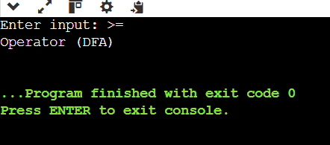

QSN 10: LEXICAL ANALYZER

Theory
A Lexical Analyzer (Scanner) is the first phase of a compiler. It converts source code into tokens.

Functions of Lexical Analyzer
- Reads input program
- Removes whitespace and comments
- Identifies tokens
- Sends tokens to syntax analyzer

Token Classification
- Keyword
- Identifier
- Operator
- Constant

Concept
The program splits a string into tokens and classifies each token based on predefined rules.
Example:
int x = 10
→ int (Keyword)
→ x (Identifier)
→ = (Operator)
→ 10 (Constant)

//Code

#include <stdio.h>
#include <ctype.h>
#include <string.h>

int main() {
char str[50];
int i;

printf("Enter input: ");
scanf("%s", str);

// Parallel states (NFA)
int isId = 1;
int isNum = 1;
int isOp = 0;

// Operator check
char *ops[] = {"+","-","*","/","%","=","==","!=","<",">","<=",">="};
int n = 12;

for (i = 0; i < n; i++) {
if (strcmp(str, ops[i]) == 0) {
isOp = 1;
break;
}
}

// Simultaneous checking
for (i = 0; str[i] != '\0'; i++) {

if (!(isalnum(str[i]) || str[i] == '_'))
isId = 0;

if (!isdigit(str[i]))
isNum = 0;
}

if (!(isalpha(str[0]) || str[0] == '_'))
isId = 0;

// Multiple accept states
if (isId)
printf("Identifier (NFA)\n");
else if (isNum)
printf("Constant (NFA)\n");
else if (isOp)
printf("Operator (NFA)\n");
else
printf("Invalid String\n");

return 0;
}

//Output

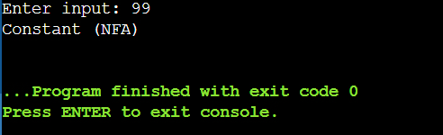

CONCLUSION
These experiments demonstrate the fundamental concepts of lexical analysis, including token identification, pattern recognition, and DFA simulation, which are essential phases in compiler design.

